Early VOCAL PEDAGOGUES: A chronological STUDY GUIDE
Giovanni Camillo Maffei (1533-1603)
Breathing/Support:
- Said “Gradually press the breath with the voice, and pay great attention that it does not go out through the nose or by the palate, for the one or the other would be a very great error”
- Describes glottal resistance to the breath/appoggio
Written Works:
- Likely authored the first comprehensive text on the voice, “Discoro della voce”
- “Delle lettere...libri due”...(1562)
Giovanni Battista Bovicelli (1555-1594)
Breathing/Support:
- Cautioned singers to be discreet in the use of breath; do not breath breathe between accented notes and ornamented passages
- Advocate a silent inhalation (he was one of the first authors to do so) (1594)
Vocal Tremulousness:
- Described a groppetto (probably similar to a modern trill), distinct from the tremolo (“trembling of the voice over a single note”)
Written Works:
- “Discorso della voce a del modo d’apparare di cantar di garganta” (1562)
- Regole, passaggi di musica

Lodovico Zacconi (1555-1627)
Biographical:
- Singer/maestro di cappella in Venice (composer, priest, inventor… Ren. Man!)
- Lived in the time when monodic song was replacing polyphonic, and virtuosic singers emerged from ranks of choristers
Breath/Support:
- Breath control- one should only use as many ornamentations as one can accommodate on a single breath
Registration/Tone:
- First description of distinct vocal registers (used terms voce di petto/testa); first pedagogue to describe a chiaroscuro tone
- Expressed preference for the bright and ringing chest voice, which “pierces a little but does not offend”; also argued chest had more power and better intonation; disliked di testa/falsetto, which he said, “was not only boring, and annoying, but in a short time one comes to hate and abhor them”
- Treatise “Prattica di musica” includes some of the earliest remarks on voice quality: differentiated between “dull” (obtuse, mute) and “biting/stinging” (mordente); Related these qualities to registration (di petto/di testa), most detailed early description of registers
Vocal Tremulousness:
- Described tremolo as a mechanism for propelling florid passages: “a boat moves with greater ease when it is already in motion…this tremolo should be narrow and attractive…. Miraculously facilitates the emission of passaggi…” called tremolo an embellishment, and is unclear if refers to modern vibrato or glottal articulation
Written Works:
- Treatise “Prattica di musica” (1743), Italian Text

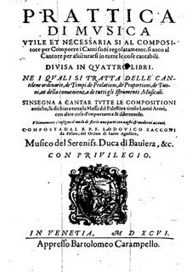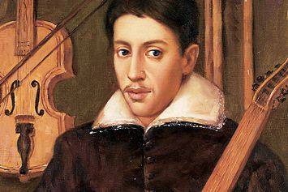
Giulio Caccini (1551-1618)
Biographical:
- Worked w/the ladies-in-waiting at the court of Ferrara (would sing madrigals as solo accompanied songs), helped with passaggi and embellishments; the ladies became very skilled at the “old florid style”
- Part of the Florentine Camerata- wanted t be known for being the “sole inventor” of the “new operatic style”
- Noted the difference between choral singing (polyphonic) and the freer solo technique (monodic)
- Reinforced Zacconi’s views ; “Le nuove musiche” (1602) includes extended preface of techniques required for new solo repertoire
Breathing/Support:
- Advocated breath economy- urged singer to avoid wasting breath with falsetto singing
- Emphasized importance of breath control in making all the gradations between soft and loud sounds

Registration/Tone:
- Referred to 2 registers as voce piena e naturale (full and natural voice), and the voce finta (feigned voice) (we now assume these are alternatives to chest/head)
- Was a “one-register” singer who advocated transposing a song to avoid difficult high notes (would not have employed “covering”)
- Described good singing in terms of vocal affetti that expressed certain emotions (articulations, ornaments, etc)
- Said one should sing with “voce piena e naturale, avoiding le voce finte- this refers to the male chest/modal voice, that does not have to “accommodate to others” as in a choral texture; disliked falsetto for its “lack of nobility,” breathiness, and inability to produce strong dynamic contrasts (usually transposed/wrote pieces to remain easily in male chest)
Vocal Tremulousness:
- Uses terms trillo and gruppo in place of earlier tremolo/gropetto, maintaining they were related
Written Works:
- “Le Nuove Musiche,” collection of monodies/basso continuo (1602)
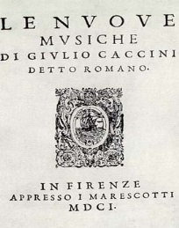 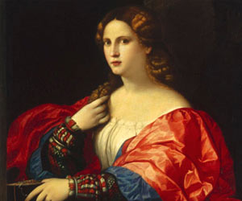(Guilo Caccini, Collection, daughter Francesca Caccini)
Pier Francesco Tosi (1653 – 1732)
Biographical:
- Castrati, composer, author
- His “Opinoni de' cantori antichi e moderni” (1723) was the first full-length treatise on singing, and provides a unique glimpse into the technical and social aspects of Baroque vocal music; Geared mostly to soprano castrati
- Wrote of the “great decline of singing” in 1723 (particularly of women); however, failed account for the simultaneous triumphs of the castrati (Bernacchi, Farnielli, Carestini)
Breathing/Support:
- Referred to messa di voce as crescendo-decrescendo
- Allowed singer to breathe in the midst of long passaggi (unlike his conetmporaries)
Registration/Tone:
- Used terms di petto and di testa to describe primary registers, and advised equalizing both to realize vocal strength and beauty; however, did not offer suggestions how to accomplish this!
- Said, “a diligent instructor, knowing that a soprano (male castrato) without falsetto must sing within a narrowness of a few notes, should not only attempt to acquire it, but should leave no means untried so that he unites it to the chest voice, in a way that one cannot distinguish the one from the other”
- Galliard, in his translation of Tosi to English, included his own 3-register theory of singing in footnotes of “Observations”
Vocal Tremulousness:
- Did not make mention of the vocal vibrato, but did discuss the trillo, which he pejoratively called the caprino (“goat-bleat”); also discussed the importance of the vocal trill and the passaggi; believed the trill to be endowed by nature, and that there were two forms, battuto (“beaten”) and scivolato (“gliding”); it is very possible the latter referenced the legato vibrato, while the former referred to glottal articulation
Written Works:
- Observations on the Florid Song, English Text

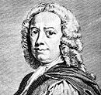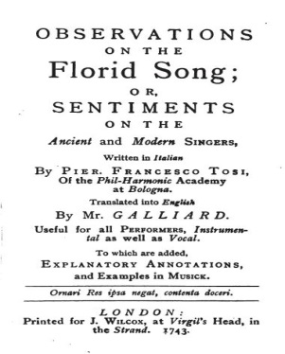

Giambattisa Mancini (1714-1800)
Biographical:
- Castrato, student of Bernacchi
Breathing/Support:
- Believed breath management to “lend great excellence to singing,” and considered messa di voce advanced technique requiring similarly advanced training but was the “secret to beautiful singing”
- Wrote “the most necessary sing for success is the art of conserving breath and managing it”
Registration/Tone:
- In line with Italian School, used 2-register model (petto/testa; uses “falsetto” and “head” interchangeably), wanted both registers to be “united into a chest register”; suggested that the head be strengthened (he considered to be generally the weaker register), but did not specify how; said (he had) “no doubt that of all the difficulties that one encounters in the art of singing, the greatest by far is the union of the two registers”
- Feels a “smiling position” aids with coloratura
- Probable first use of term chiaroscuro (1774) in “Pensieri e riflessioni pratiche sopra il canto figurato,” which also explains trills, messa di voce
- Like Tosi, argued that great singing was in an age of decline (after listing many great living singers!)
Vocal Tremulousness:
- Unlike Tosi, believed anyone could learn to sing trills, and they were an “indispensable necessity;” strongly criticized glottal trills
Written Works:
- Practial Reflections on the Figurative Art of Singing, Text
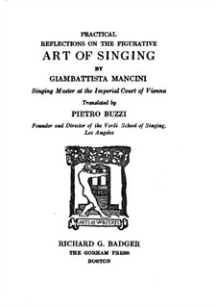
Manuel Garcia II (1805-1906)
Biographical:
- “(with Garcia) Tradition and science not only met, but collided with a force that is still felt today.”“Works considered by many to be the key to the ‘old Italian school of singing” “Heir to Italian school”-Stark; however, defied many of the time-honored precepts of Old Italian School with scientific discoveries, polarized the field of vocal pedagogy with the introduction of the laryngoscope
- Operatic Tenor, pressured by father Manuel Garcia (a famous singer from Seville who became Rossini’s favorite tenor) to take on mature Mozart and Rossini roles during pubertal mutation of his voice, singing voice “ruined” at 24
- Professor at the Paris Conservatoire (firmly in the Italian tradition), penned “École de Garcia: Traité complet de l’art du chant” in 1841, which cites Tosi, Mancini, Herbst, Agricola, etc, tries to unite 2- and 3- register theories (and the multitude of terms that were being created to define registers!)
- In 1855, discovers use of laryngoscope to observe vocal function and performs laryngeal dissection, allowing for unprecedented understanding of anatomical detail; scope becomes chief diagnostic tool in medical practice of laryngology; “Father of modern voice science”
- Invited by Wagner to train singers at Bayreuth (and wrote to Garcia, praising him as the best teacher of the Old Italian method)
- Taught until death at 101, famous pupils including Mathilde Marchesi, Joanna Wagner, Jenny Lind, and Julius Stockhausen
Breathing/Support:
- Garcia’s Messa di voce, unlike Mancini, included a register change from falsetto (loose closure) to chest (firm closure); thought was “best test of breath support” and “not for beginners,” involving both timbre and register (and volume!)
- Outside of the messa di voce (which Garcia referred to as the spianata di voce, or the “smoothing” of the voice), did not speak extensively of breathing techniques
- Inspiration not a major element of his method, but does speak of relationship between glottal resistance and breath pressure throughout his works
Registration/Tone:
- Originally refers to female middle voice as “falsetto,” and described two distinct approaches for how men could achieve upper extension; according to Stark, he likely preferred looser phonation and relaxed, open pharynx (resulting in a sound low in high-fz compounds, a quiet “half-voice”
- In 1840, established his career by presenting “Mémoire sur la voix humaine” to the Académie des sciences de Paris; report stated that height of larynx changed pharyngeal shape (and also described registers as chest, FALSETTO, with head as the upper extension of falsetto! This furthered confusion, although he was not the first author to assert this)
- Explained the mechanical principle of the two being different (chest, folds vibrate full length and depth… head, only inner margins of folds; he added the position of the arytenoids being involved)
- Believed singers should have strong concept of anatomy and function, and explored the vocal SOURCE over vocal tract
- Supported a raised soft palate and expanded pharynx
- Maintained that timbre modifications could help unite registers
- Never used term chiaroscurio, although appears to maintain a similar aesthetic ideal to the Lamperti school
- First to thoroughly explain source/filter distinction, as well as the role of laryngeal position in chiaroscuro (he never used the term specifically)
- Proponent of coup de la glotte, or “stroke of the glottis” (literally, “blow of the glottis”) which asserts that firm
glottal closure (strong adduction and a shortened glottis) will create increased efficiency of airflow resulting in a fuller, brighter quality (éclat); discouraged stroke of the “chest” (poitrine)
- CDLG intended to ensure a ringing quality (voix éclante), and avoid loose closure/”veiled voice” (voix sourde), with clair or sombre modifications made in the vocal tract, effecting the “tints” of the voice; a “two-pronged theory”
- Belived [i] best to vocalize on initially, as modeled brilliancy for other vowels
- “Traité” describes as beginning with a closed glottis (prephonatory), which builds subglottic air pressure, which is then “(opened) with a….vigorous stroke,” similar to the creation of labial plosives
- Stated, “When one very vigorously pinches the arytenoids together… Each molecule of air is subjected to the laws of vibration and the voice takes on a very pronounced brilliance,” which he advocated for singing with a brilliant tone
- Said “The vowels should always be attacked by the coup de la glotte, and with the degree of force that is appropriate to the phrase; one should…avoid having them preceded by an aspiration”
- First author to discuss vocal onset in detail; believed that this “first instant of phonation” was key to the cultivated tone quality required for operatic and concert singing
- Described 2 glottal settings, the “5/5” glottis (both membranous and cartilaginous portions of fold vibrate) and the “3/5” (membranous only vibrate due to “pinched” arytenoids) : he advocated later for bright tone and low airflow (as opposed to former, yielding veiled tone and wasted air)
- Note: 3/5 is similar to Pressman (1942) “damping”, when only anterior portions of folds are used to produce high notes, as well as Mackenzie “stop closure,” Catford’s “anterior phonation,” and Laver’s “tense” voice, all resulting in shortened glottis
- Frequently misunderstood by peers, who interpreted as a “shock” rather than continued adduction, and failed to understand the “pinch” (pre-phonatory closure)
- Final work, “Hints on Singing” (1894), responds to criticisms of his methods (largely unchanged after 1841 treatise); talks more about mechanical differences in vocal registers (by this point, he had adopted a 3 register model, chest, medium, and head)
- First to provide actual techniques for uniting registers, which he believed could be achieved by firm glottal closure and passing from D4-F4 with CDLG (believed both glottal source and vocal tract made this possible)
- Also wrote about various extended vocal techniques (which he could not always explain, but was aware of) like overtone singing, strohbass, etc
- Advocates of CDLG included: Dr. Louis Mandl, Stockhausen, Marchesi (M and Blanche); Great “enemies” of CDLG included: Mackinglay, Myer, Lunn, Holbrook, Curtis, Shaw (Meyer and Shaw head of “no-effort school”), Clippinger, McKenzie
Vocal Tremulousness:
- Had very negative views on vibrato, cautioning against use in all but most emotional passages (possible that he was referring to excessive oscillation, not “normal” vibrato; we know Nellie Melba’s vibrato was of the Garcia School, and referred to in writing as “flawless”)
- Described the trill as a “loose and swift oscillation of the larynx” and a “spontaneous trembling of the throat” which could be learned by anyone
Written Works:
- “Mémoire sur la voix humaine” (1840)
- “École de Garcia: Traité complet de l’art du chant” (1841)
- The Art of Singing, Text
- Hints on Singing, Text
- Methods and Exercises for Singing, Text

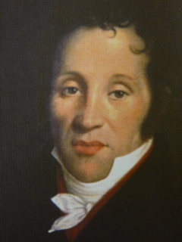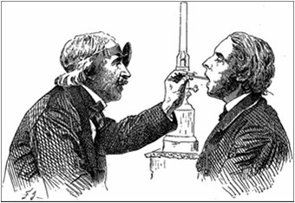 (Garcia I, Garcia II)

Mathilde MarChesi (1821-1913)
Biographical:
- German singer, moved to Paris to study with Garcia, most important of Garcia’s students in terms of forwarding his precepts of singing
- Stressed the importance of good singing regardless of the level of dramaticism; Stressed the importance of a natural breathing method, vocal registration, and intelligent, paced practice as a beginner
- Students included Mary Garden, Nellie Melba, (daughter and teacher) Blache; known for success with the female voice, particularly sopranos
Registration/Tone:
- Along with her daughter Blanche, one of primary advocates of Garcia’s coup de la glotte; her own manual, “Méthod de chant théorique et pratique”(1885) follows Garcia’s directions towards a “prepared onset,” closing the glottis directly before expiration, and keeping the glottis closed for the duration of phonation
- Attacks from Henry Holbrook Curtis and others created the bipartisan schools of “local-effort singing” and “no-effort singing”; critics of the former believed that scientific efforts to change “natural” production were an affront to centuries of singing tradition
- Said, “if the vocal cords are not firmly and evenly closed throughout their entire extent at the instant that the air commences to escape from the lungs, they will be weak and hoarse…the firmer and more complete the approximation of the lips of the glottis, the more resistance they will offer to the air and the less air it will take to set the vocal cords vibrating”
- Liked “natural singing” over the “smiling” (ie, lifted cheekbones) position common at the time
- Rejected Garcia’s 2 register model in favor of his 3-reg; believed care needed to be taken to “close” ascending and “open” descending between breaks (sounds similar to Garcia’s “pinch the glottis” in same areas); said “registration is the alpha and the omega of the formation and development of the female voice” and believed that she made her greatest contributions to pedagogy in the area of registration

Written Works:
- Published Material: “Marchesi and Music: Passages from the life of a famous singing teacher” (1898) “Ten Singing Lessons” (1901) “Bel Canto: A Theoretical and Practical Vocal Method” (1970)
- Art du chant, Op.21
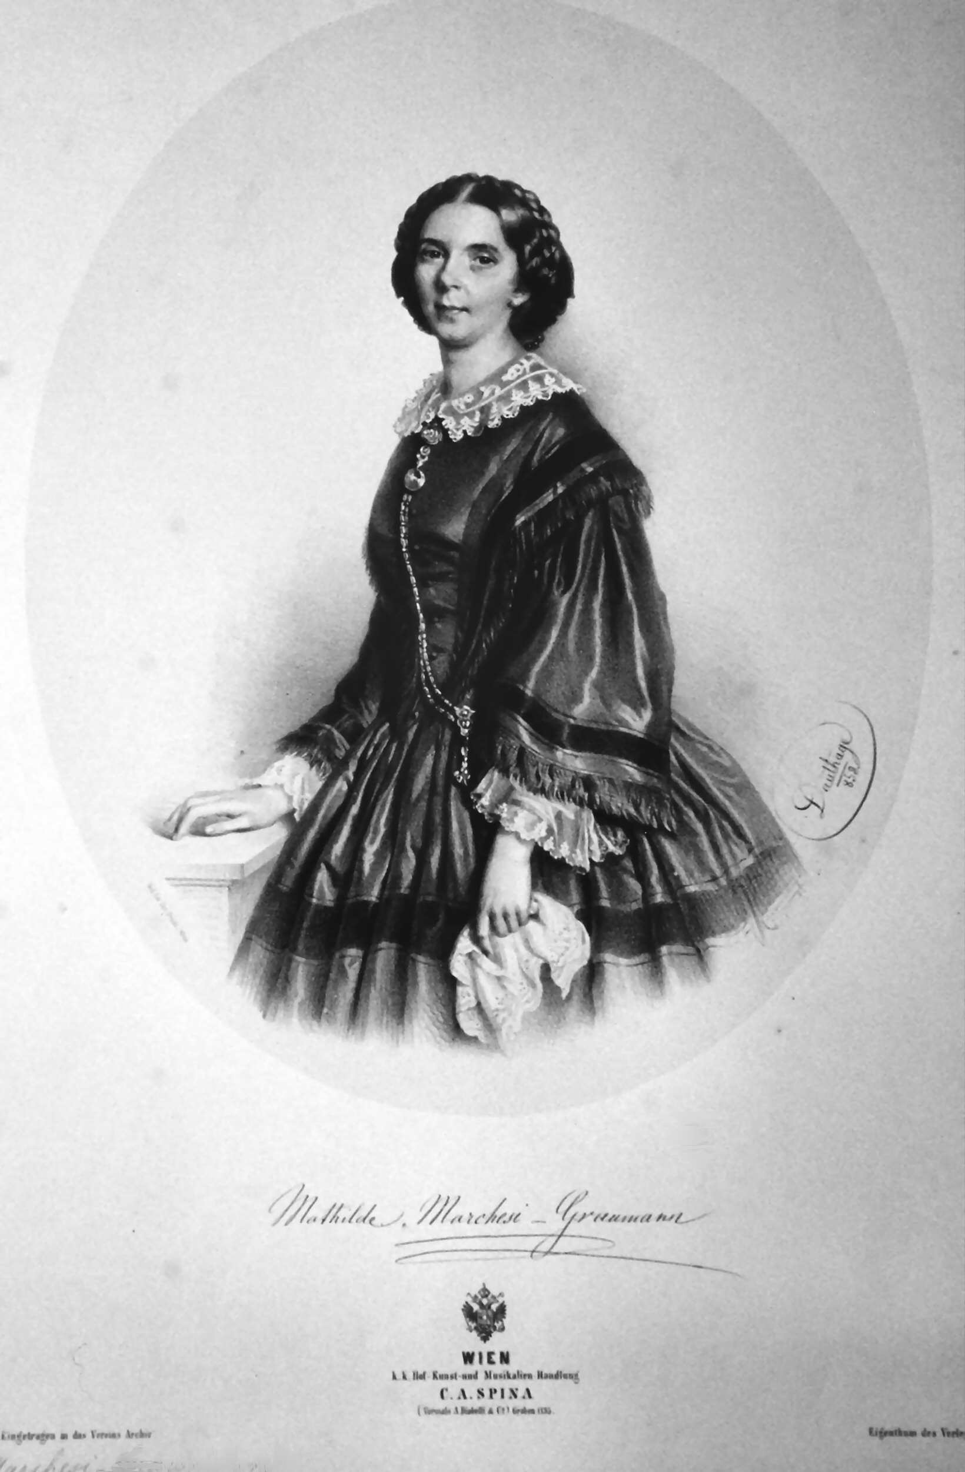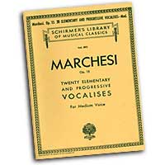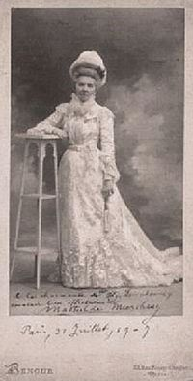

Julius Stockhausen (1826-1906)
- Expanded on Garcia’s method of teaching (his pupil), emphasizing beautiful sound as the basis for expression
- Lowered Larynx; Two modes of vocal fold vibration and three registers; believed many men ignored middle voice, excepting some tenors using head voice; similarly, believed that sopranos only used falsetto and head, registers could be mixed by using a “sombre” quality ascending and “clear” quality descending; here, only spoke of vocal tract, not glottal setting
- Emphasized combination of diaphragmatic breathing and rib breathing to allow a full breath (respire pieno)
- Staccato for females, martellato for males
- Called the messa di voce the “basis of voice culture”
- “Method of Singing” (1884)
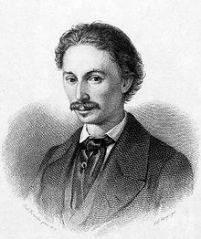
Henry HolBrook Curtis (1856-1920)
- “Enemy” of CDLG, Blanche Marchesi “blamed” new school of resonance imagery on him; said “the shock, or the CDLG, is death to the voice; it is born of ignorance, and to teach or allow its continuance is a crime. We have no words strong enough to condemn it”
- Vocal member of “No effort school” (a term coined by Shaw, that included Curtis, Shaw, Meyer, Clippinger, Henderson)
- Champion of the “relaxed throat,” and that “placing the tone in the facial resonators induced new plan of vibration of the vocal cords” (dans le masque), a nasal quality antithetical to Garcia’s high palate and expanded pharynx

Franceso (1811-1892) and Giovanni (1839-1910) Battista Lamperti
Biographical:
- Legacy includes William Shakespeare, Herbert Witherspoon, William Earl Brown
- Differences in opinion between Garcia and Lampertis topic of heated discussion throughout Europe (became two “schools” of Bel Canto)
- FL and GL also disagreed about Wagner; G’s essay “Preventing the Decadence of the Art of Singing” focused upon the necessity of building a solid vocal technique as the way to preserve good singing, and defended Wagner’s music; FL believed that a voice trained in the Old Italian Tradition was not suited to the demands of Verdi and Wagner
Breathing/Support:
- FL fully introduced and entrenched term appoggio to literature (not using more air than necessary), credited with many attributes of good singing; defined as “all of the notes, from the lowest to the highest, are produced by a column of air over which the singer has perfect command, by holding back the breath, and not permitting more air than is absolutely necessary for the formation of the note to escape from the lungs”
- Advocated singing with “compressed breath” (high subglottal breath pressures-controversial, suggests vocal strain to some); heavily endorsed diaphragmatic/abdominal breathing, and warned against breathy onsets, particularly with [a]; endorsed Dr. Louis Mandl’s idea of lutte vocale, or “vocal struggle” and admonished singers to avoid noisy, lateral, or clavicular breaths; said “any effort about the chest-ribs in breathing must be absolutely and entirely avoided”
- Used “Candle exercise” to check for wasted breath: “hold a lighted taper to (your) mouth: if the flame does not flicker during the emission of sound, it shows that the sound is gently emitted, and proves him to be a master of respiration”
- Emphasized posture, use of the muscles of the thorax in singing
- G believed the Italian language was superior for singing because it was the only one lacking aspirates (detrimental to compressed breath and the steadiness of the legato line)
Registration/Tone:
- Writings best represented the largely oral tradition of the “traditional school of voice teaching”; did not use many physiological/acoustic terms (ergo, comments on pedagogy sometimes vague and difficult to interpret); example, voce aperta versus voce chiusa passage (Giovanni preferred “closed” over “covered,” finding the former misleading)
- FL Advocated a dark tone with expanded pharynx as starting point to later be brightened to create chiaroscuro tone; wrote “…Although you may acquire a wide range of voice, you cannot modulate the sounds until the resonance of your tone be round and rich, chiaroscuro”
- FL said, “no such thing as nasal voice, head voice,” etc.; Heavily used imagery, but recognized such imagery was illusory, and that the voice could not be “placed” (GL fell back on such imagery occasionally...)
- FL believed in 3 registers for women (chest/mix/head), 2-register model in men (only chest/mix- likely did not deal with falsetto); both treated registers, breathing, and timbres as a whole; GL ascribed to 3 for women, and 4 for men
- Considered chiaroscuro (holdover from Mancini!) still considered tonal ideal
- In messa di voce, entire exercise performed with strong closure, with crescendo-decrescendo manipulated via breath pressure; ascribed to Garaude’s (not Garcia’s) definition of the exercise, saying that loud and soft; tones should be the same in all respects except for volume; GL called it “the most difficult problem in singing”; often began with strong sound and then established ability to decrescendo
- GL stated that men had a 4th register that was called the “mixed voice” (he asserted was underused, which is why there were so few tenors of note!), like teaching using mirrors and believed strongly that teacher should not accompany or sing along to pupil
Vocal Tremulousness:
- F. Lamperti distinguished between a “good” and “bad” vibrato, remarked that tremulousness was distinct from vocal oscillation, which was a positive attribute of a “strong, vibrating, sonorous voice”
Written Works:
- FL wrote “Guida teorico pratica elementare per lo studio del canto” (1864), and “A Treatise on the Art of Singing” (appeared in English 1871), “L’arte del canto” (1883)
Giovanni wrote “The Technics [sic] of Bel Canto” (1905), teachings best known today through “Vocal Wisdom: Maxims of Giovanni Battista Lamperti” (prepared by his pupil, published posthumously 1931); stressed diaphragmatic breathing, thought breath control should be foundation of all study (only breathing through the mouth acceptable); he also accepted the action of auxiliary muscles of breathing (such as the intercostals) in order to ensure a “compressed” breath
- Volume of F Lamperti maxisms published posthumously by former student, William Earl Brown

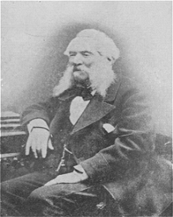
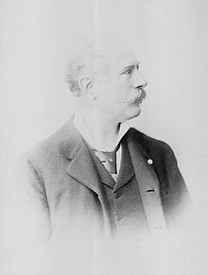Francesco, Giovanni
- F. Lamperti, The Art of Singing
- G. Lamperti, Die Technik des Bel Canto

Luisa Tetrazzini (1871 –1940)
- Italian coloratura soprano of great international fame (principal rival, Nellie Melba)
- Advocated “back breathing”
- Co-author, “Caruso and Tetrazzini on the Art of Singing” (1909)
- Caruso and Tetrazzini on the Art of Singing, Text
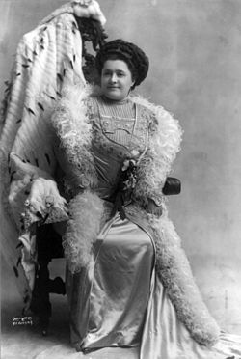
William VennarD (1909-1971)
Biographical:
- Pioneered new scientific information in the singing mechanism, disbanding previous belief of bel canto singing and combining physics, psychology and voice science
- Conducted experiments proving nasal cavity unimportant to singing, but believed there was evidence that when we are learning “the shaping of the cavities above the larynx, we are training the vocal cords unconsciously at the same time”

Breathing/Support:
- Well-known Californian voice teacher and researcher, fascinated with Van den Berg’s explanation of Bernouli Effect (“velocity and pressure are inversely proportional in any ‘streamline’ of fluid flow”; ie, airstream in trachea has constant velocity until reaches glottal restriction- increased velocity at the glottis creates negative pressure, causing vocal folds to slap together”), suggested to “flood the tone with breath,” and to begin tone with an aspirate, “imaginary h” to bring folds together; believed this explained Garcia’s coup de la glotte (Titze determined that for SUSTAINED vibration, air alone not adequate to close glottis)
Registration/Tone:
- Discussed heavy and light mechanisms, determined the lamina propria to be the vibrating membrane, and vocal resonance as a product of vocal registration
- Role of cuperto in developing registration balance
- Explained messa di voce as “transition from one mode of laryngeal vibration to another”
- Imaginary h” as a mean of beginning phonation, which he believed came nearer to meeting the condition of CDLG as described by Garcia; Garcia actually said that one should “scrupulously avoid having (vowels) preceded by aspiration”
- Maintained (not the first) that ideal voice qualities possess a low and a high formant (chiaroscuro?)
”
Written Works:
- “Singing, the Mechanism and the Technique” (1967)
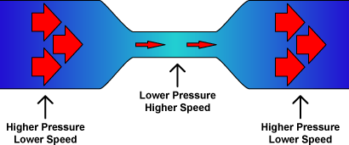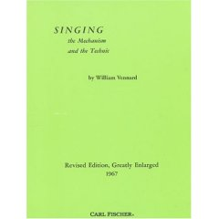

Richard Miller (1926-2009)
Biographical:
- Along with Garcia, likely the most influential of all vocal pedagogues
- Used science as a basis for teaching and stressed the importance for a complete coordination of systems working as interdependently. Voice building exercises starting basic and becoming more intricate, stressed the proper development of the voice with thorough exercise
Breathing/Support:
- Coordination of the breath and laryngeal mechanisms; cites Lamperti’s ideas on appoggio

Registration/Tone:
- “Laryngeal source” of chiaroscuro (source and resonating system interact in such a way as to present a spectrum of harmonics)
- Maintains that male voices have both a primo passaggio and a secondo passaggio, with a zona di passaggio in between them
- Described stauprinzip as a robust use of the voice requiring high subglottic pressures and muscular tension similar to a painful groan, and the secret to many Heldentenore
- Maintains registration solidification achieved through resonance training
Vocal Tremulousness:
- Speculates that the slower vibrato rate of 20th century singers (as opposed to documented rates in the 19th century) may be due to the cultivation of a darker tone quality associated with chiaroscuro and appoggio
Written Works:
- Author of many texts, including “The Structure of Singing” (1986)

Johan Sundberg (1936-)
- Primarily an acoustician, warns against firm glottal closure; defined three types of phonation: “breathy,” “flow,” and “pressed;” stated “pressed phonation is characterized by high subglottic pressure combined with a strong adductive force, while flow phonation has a lower subglottic pressure and a lower degree of adductive force”
- Says that pressed phonation is caused by high subglottic pressure combined with strong adductive force (NOT referring to position of arytenoids, but ratio of subglottal pressure to transglottal airflow), and “affiliated with raised larynx;” prefers flow phonation, which results in a tone suitable for a choral blend
- Discussed formant tuning, particularly on high soprano notes
- Suggested nasal resonance not relevant to major acoustical properties of vowels produced in professional opera singers

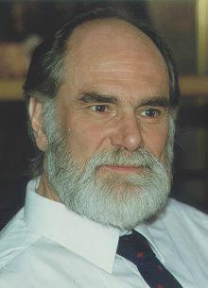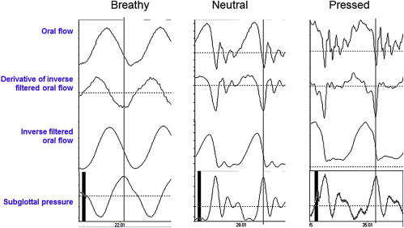

James Stark (1938-)
- Author of “Bel Canto;” deduces firm phonation to be an “unnatural” vocal adjustment not appropriate to all genres of singing (says is absent in popular forms), believes the CDLG to be “arguably most important development in history of singing”
- Assesses modern registration as being a largely 2-register model, with “auxillary” registers at the top of a soprano and bottom of a bass’ voice
- Recreated some of Garcia’s experiments (“Groningen Protocols”), and is open to the possibility that firm closure may not be damaging to the voice, but instead represent fine muscle control
- Agrees with Lamperti’s “low” breathing patterns to prevent “clutching” at the larynx; defines appoggio as a complex coordination of all the muscles of singing, rooted in the equilibrium between breath pressure and controlled phonation
- Provides an in-depth timeline of the development of vocal pedagogy from the early 16th century to present day. Uses Garcia’s treatise as a point of reference to compare and contrast the bel canto singing style and its controversies
Ingo Titze
- Introduced physics into the vocal mechanism and uses acoustic and breath/muscular principles in physiology
- Acoustical development in vocal production
- Voice therapy as a voice building tool
- Myoelastic- aerodynamic principles in singing
- Bernoulli effect cannot distinguish the inward-outward movement of vocal folds
- States that singers execute messa di voce in different ways
- Voice scientist, also in favor of flow phonation; defines pressed phonation as “tight adduction” (hyperadduction), and breathy as “loose adduction” (hypoadduction) with optimal voice in the middle, but “on the breathy side”
- Concerned with the impact stress of tight adduction, prefers flow in order to avoid potential damage of pressed phonation

The “Little but important” Guys/Gals (Alphabetical)

Johann Agricola (1757)
- Suggested that falsetto (Fistelstimme) was sung with a high larynx (ergo, a forced quality), also mentioned “low falsetto” (likely pulse register/strohbass)- although widely read, unfortunately, a “dabbler” with a faulty sense of physiology; long descriptions of registration being properties of the windpipe and glottis
- Wrote, “It is of great advantage in uniting the natural with the falsetto note in the upper register if one can produce the intermediate note, the highest of the one and the lowest of the other, with both kinds of voice”
- Joined many 17th-18th century authors in comparing vocal vibrato to string vibrato

Jean Baptiste Bérnard (1755)
- Wrote “all of the art of singing consists of correct raising and lowering of the larynx, and good inspiration and expiration;” much of his method involved laryngeal adjustment
- “L’art du chant,” 1755, available on Google Books: "L'art du chant" (1755)

Dominico Pietro Cerone (1613)
- Principal early Spanish treatise on singing, “El melopeo,” discusses period throat articulations; “the fine singer does more with his ear than his mouth”

Emil Froeschels
- Introduced term hyperfunction, referring to excessive force of the larynx, and hypofunction for muscular exhaustion and the condition of paratetic hoarseness

J.E. Galliard (1743)
- Appended own views to Tosi, describing three distinct registers instead of two (separating head and falsetto); became one of first to do so: “Voce di petto is a full voice… voce di testa… comes more from the throat than the breast… falsetto is a feigned voice… but is of no substance”
Garaudé (1830)
- Garcia mentor; author of “Méthod complète de chant,” preferred chest voice with “round, sonorous quality;” In 1830, wrote of the voix mixte which extended male chest voice up a few notes above passaggio (concealing register transition without a “hard” break), up to Bb4, which may be how Rossini intended top pitches to be sung
- Said that when singing the messa di voce the registers should remain the same regardless of the force of the voice, and one should not use the voce di testa

Hermann Hemholtz (1821-1894)
- Responsible for developing the framework that would later become formant theory

Johannes Herbst (1588-1666)
- 17th century ped, influenced by Caccini and Praetorius, believed falsetto to be a “half and forced voice”

Dr. Louis Mandl (1876)
- Credited with coining the term lutte vocale (“vocal struggle”)

Jean Paul Egide Martini (1741-1816)
- Described 3 female registers (voix de poitrine, voix du gozier (throat), voix de tête for high; Bernando Mengozzi followed maintaining contraltos and mezzos have 2 reg, but sopranos have 3 (chest, middle, head)

Bernardo Mengozzi (1758-1800)
- (also mentor of Garcia’s); Posthumous treatise of 1803, presented a theory of mixed/blended registers
- Wrote “Méthode de chant du Conservatoire de musique”

Alessandro Moreschi (1858-1922)
- Only castrato to make sound recordings (1904 Gounod “Ave Maria”) Last Catrato recording, "Ave Maria"

Michael Praetorius (1571-1621)
- Translated much of Caccini’s work into German, published “Syntagma Musicum” (1619) (encyclopedic record of contemporary musical practices)

Henry Rubin and Charles Hirt
- Used high speed motion pictures of vocal fold behavior to reveal two primary registers (showing the chest voice using the entire length and depth of the vocal folds, “momentary chaos” at the break, and falsetto mode, where the folds continued to vibrate at the same rate but barely touched)
- Believe that the registers can be blended
- Observed that in well-trained voices (especially female), strong glottal adduction allowed the vocal fold action in the upper register to more closely resemble the lower register

Emma Seiler
- One of first singer-scientists to follow Garcia in use of laryngoscope, music student of F. Wieck and science student of Helmholtz, wrote “The Voice in Singing” (1868), proposed a 5-register theory of singing, criticized practice of unnaturally “carrying up” registers beyond natural limits
- Described voice as “vibrating column of air which rebounds immediately behind front teeth”

William Shakespeare (1849-1931)
- English voice teacher, F. Lamperti’s pupil, brought Italian techniques to English readership in first decades of 20th centrury (1899, “The Art of Singing”)
- Wanted breath for singing to appear natural; unlike his teacher, combined diaphragmatic breathing with rib breathing, while describing appoggio very similarly to Mandl and Lamperti; combined with elaborate resonance imagery strategies (many based on teeth)
- Believed poor breathing caused tension in jaw/throat/tongue, and that students needed to sing with the breath to have an “open throat” (implying a raised palate and elongated resonating tube)
- Had a very strong grasp on vocal pedagogy history, quoted Tosi, Caccini, Agricola, etc.
- Advocated efficient (over loose) glottal closure, interpreted messa di voce similar to Garcia (w/register change)

Janwillem van den Berg
- 1960 article (based on experiments with excised larynges), proposed “new and simple” concept of 2 register theory- active longitudinal tension/passive tension, reinforced by high-speed motion pictures of Rubin and Hirt (in chest, full fold vibrating, “chaos” at break, shifts to light touching in falsetto mode where only margins vibrate)
- Said “the mid voice is not really an ‘independent’ register, but a ‘mixture’ of chest and falsetto register

